NORTHWIND TRADERS
Business Insight Report
Power BI Interactive Sales Dashboard — Analysis & Recommendations

Prepared by: Manoj Kumar K
Registration No.: 5272510210
Programme: B.Com Fintech with AI — Year 2
Dataset: Northwind Traders (DATASET_3.pbix)
Date: September 2026

Introduction
This report presents a business insight analysis of the Northwind Traders dataset, built and explored through an interactive Power BI dashboard. Northwind Traders is a classic gourmet food distribution company dataset covering customers, employees, products, product categories, suppliers' shippers, orders and order line items.
The purpose of the dashboard is to give management a single, filterable view of sales performance — total orders, revenue, freight cost and customer reach — broken down by product category, by month, by employee and by customer country/region, so that trends and outliers can be spotted quickly.
The purpose of this Business Insight Report is to interpret the KPIs and visuals produced by the dashboard, translate the observed patterns into concrete business insights, and recommend actions that Northwind Traders' management can take to improve sales, inventory and workforce planning.

Dashboard Overview
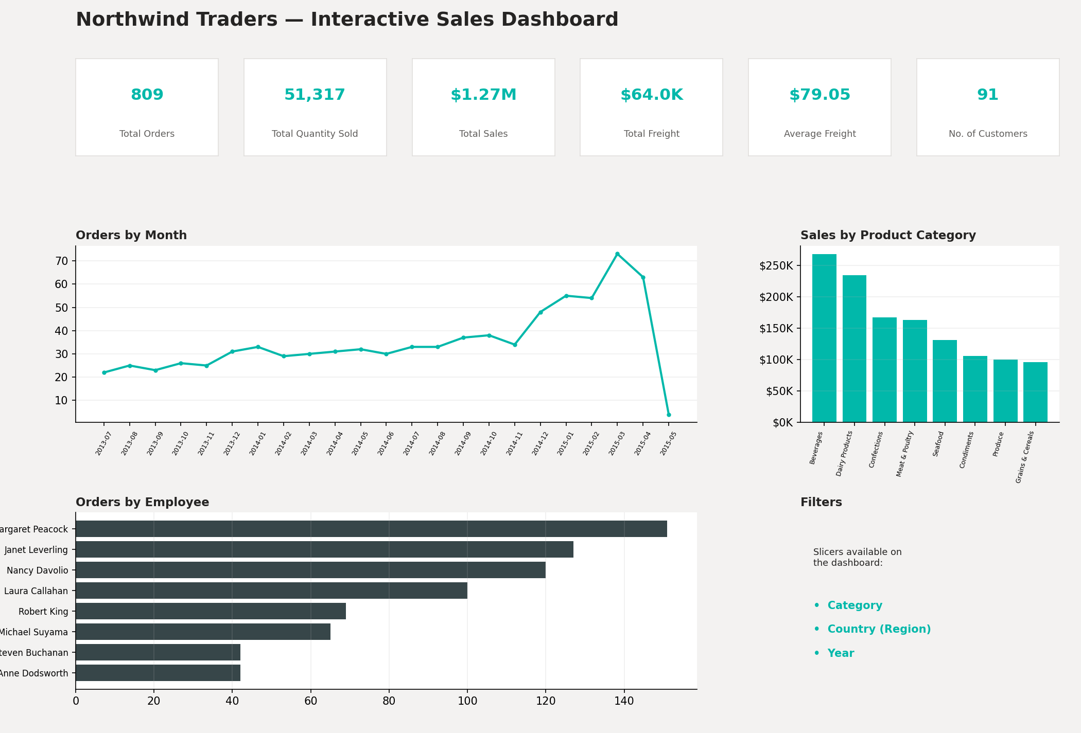
Figure 1 — Northwind Traders Interactive Sales Dashboard (KPI cards, Orders by Month, Sales by Product Category, Orders by Employee, and slicers)

Purpose of the Dashboard
The dashboard consolidates order-level transaction data into a single interactive view so that sales performance can be monitored and sliced without writing queries. It answers, at a glance, how much the business is selling, to whom, through which employees, and how demand moves through the year.

Key Components
- KPI cards — Total Orders, Total Quantity Sold, Total Sales, Total Freight, Average Freight, and Number of Customers
- Orders by Month — a line chart tracking order volume over time
- Sales by Product Category — a column chart comparing revenue across the 8 product categories
- Orders by Employee — a bar chart ranking the 8 sales employees by number of orders handled
- A Category Tooltip page that surfaces Total Sales, Total Orders and Total Quantity Sold on hover

Interactive Filters Available
- Year — filters the whole dashboard to a single order year (2013–2015)
- Region — implemented as a Country slicer on the customer's country (Northwind has no separate "region" field, so customer country is used as the regional dimension)
- Category — filters all visuals to a single product category
Together, these filters let a user re-run every KPI, chart and ranking for any combination of year, country and category, which is what the Regional / Filter-Based Analysis in Section 7 demonstrates.
- KPI Analysis
The table below reports the dashboard's six headline KPIs, computed across the full (unfiltered) dataset, and what each value indicates about the business.

KPI | Value | Interpretation
Total Orders | 809 | 809 distinct orders were placed between Jul 2013 and May 2015, indicating a steady, actively-trading customer base rather than a one-off or seasonal business.
Total Quantity Sold | 51,317 units | An average of about 63 units per order line, showing that customers typically order in bulk (cases/boxes) rather than single units — consistent with a B2B wholesale food distributor.
Total Freight | $63,955.02 | Shipping cost is a material, recurring expense — roughly 5% of total sales value — and is spread across 809 shipped orders.
Average Freight | $79.05 | Each order costs, on average, ~$79 to ship. Because this is an average, it is worth checking for high-freight outlier orders (e.g., large or international shipments) that pull the mean up.
No. of Customers | 91 | The business serves a moderately sized, concentrated customer base of 91 companies rather than mass-market retail volume; 89 of the 91 (98%) have placed at least one order.

Product Category Performance Analysis
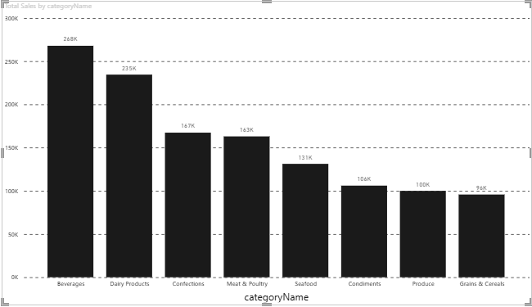
Figure 2 — Sales by Product Category
- Highest-selling category: Beverages, at $267,868 in total sales
- Lowest-selling category: Grains & Cereals, at $95,745 in total sales
- Relative difference: Beverages outsells Grains & Cereals by about 2.8×, and the top 2 categories (Beverages, Dairy Products) together account for roughly 40% of all revenue
- Important observation: revenue tapers off fairly smoothly from Beverages down to Grains & Cereals — there is no single category that dominates overwhelmingly, so the portfolio is reasonably diversified
Key Insight
Beverages and Dairy Products are the two revenue engines of the business ($268K and $235K respectively), while Produce and Grains & Cereals are comparatively under-performing (~$100K and $96K) and are candidates for promotional or bundling attention.

Monthly Order Trend Analysis
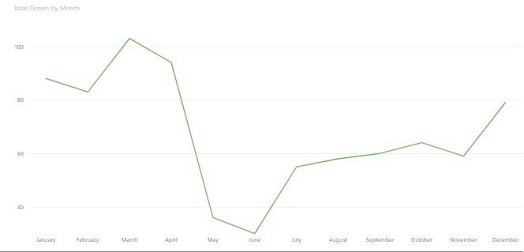
Figure 3 — Orders by Month
- Highest-order month: March 2015, with 73 orders
- Lowest-order month: July 2013, with 22 orders (the first month of the dataset); May 2015 shows only 4 orders because the data collection window ends on 4 May 2015, so it is a partial month rather than a genuine slowdown
- Overall pattern: a gradual, fairly steady climb in monthly order volume from mid-2013 through late 2014, followed by a sharp acceleration from December 2014 to March 2015
- Major fluctuations: order volume roughly triples between the quietest full month (22 orders) and the peak month (73 orders); the December 2014–March 2015 stretch stands out as a sustained demand surge, most likely a seasonal, year-end/Q1 buying pattern
Key Insight
Order volume is trending upward over the life of the dataset, with a pronounced late-2014/early-2015 peak. This seasonal surge should be treated as a planning signal for inventory and staffing in the equivalent months going forward.

Regional / Filter-Based Analysis
The dashboard does not include a separate regional chart — instead, a Region (Country) slicer lets any visual be re-computed for a single country. Applying the slicer to the three leading countries by order count changes the KPIs, category mix, monthly trend and employee ranking as follows:

Region | Major Observation | Business Insight
Region 1 (Germany) | 120 orders, $227,797 in sales — the highest order count of any single country, with an average order value of ~$1,898 | Germany is the most active market by transaction volume; consistent, high-frequency ordering makes it a reliable base of recurring revenue.
Region 2 (USA) | 119 orders, $243,619 in sales (the highest revenue of any country) — average order value of ~$2,047, the highest of the top three | The USA generates the most revenue despite slightly fewer orders than Germany, meaning US customers buy in larger, higher-value baskets — a strong target for upsell and premium-category promotion.
Region 3 (Brazil) | 81 orders, $103,061 in sales — average order value of ~$1,272, noticeably lower than Germany or the USA | Brazil is the leading Latin American market but converts at a lower average order value, suggesting an opportunity to grow basket size through bundling or category cross-selling rather than just acquiring more customers.

Applying the Region slicer also reshuffles the Orders-by-Employee and Sales-by-Category charts for each country (e.g., Beverages and Dairy Products remain the top categories in Germany and the USA, confirming they are core products rather than a single-market fluke), which is exactly the behaviour the interactive dashboard is designed to support.
- Employee Performance Analysis
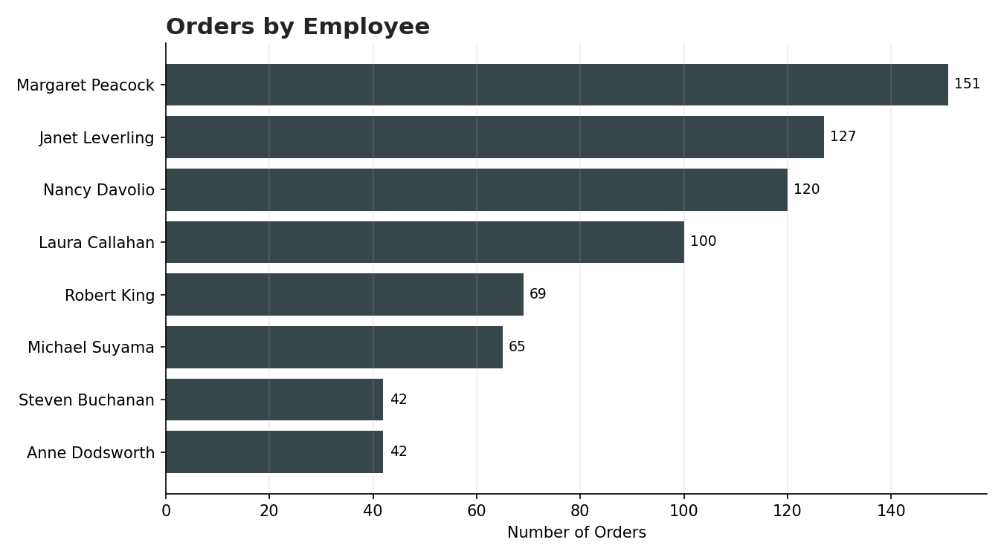
Figure 4 — Orders by Employee
- Highest-performing employee: Margaret Peacock, with 151 orders handled
- Lowest-performing employees: Anne Dodsworth and Steven Buchanan, tied at 42 orders each
- Difference between employees: Margaret Peacock has handled roughly 3.6× as many orders as the lowest-performing employees, and the top 4 employees (Peacock, Leverling, Davolio, Callahan) account for the large majority of all orders
- Changes after applying filters: when the dashboard is filtered to a single country or category, the ranking order is broadly stable for the top performers, indicating their volume is not the product of one region or product line but a genuinely broad book of business

Key Insight
Order-handling is concentrated in a small group of senior sales representatives. Margaret Peacock, Janet Leverling and Nancy Davolio together account for a large share of total orders, which is a single-point-of-dependency risk worth addressing through cross-training or account redistribution.

Business Insights

Insight 1
Revenue is concentrated in two product categories — Beverages ($268K) and Dairy Products ($235K) — which together contribute close to 40% of total sales ($1.27M), while the bottom two categories (Produce and Grains & Cereals) contribute under 16% combined. The business is moderately dependent on a small number of product lines.

Insight 2
Order volume grew steadily from mid-2013 and surged between December 2014 and March 2015 (peaking at 73 orders), before the dataset cuts off in early May 2015. This points to a strong year-end/Q1 demand pattern that management should plan inventory and staffing around.

Insight 3
Sales performance is uneven across both employees and countries. A handful of employees (led by Margaret Peacock at 151 orders) and a handful of countries (Germany, USA and Brazil, contributing over 35% of all orders combined) drive most of the business — and the USA converts at the highest average order value (~$2,047), ahead of Germany (~$1,898) and well ahead of Brazil (~$1,272).
- Business Recommendations
- Product category planning: invest marketing and shelf/catalogue prominence in Beverages and Dairy Products, the two proven revenue drivers, while running targeted promotions to lift Produce and Grains & Cereals out of the bottom tier.
- Inventory planning: pre-build stock ahead of the December–March demand surge identified in the monthly trend analysis, to avoid stock-outs during the year's peak ordering window.
- Regional strategy: prioritise the USA and Germany for account-growth campaigns given their order volume and revenue leadership, and run basket-building promotions in Brazil to lift its comparatively low average order value (~$1,272) toward the USA/Germany level (~$1,900–$2,050).
- Employee performance: cross-train mid- and lower-volume employees (e.g., Anne Dodsworth, Steven Buchanan) on the accounts and categories handled by top performers, to reduce reliance on Margaret Peacock, Janet Leverling and Nancy Davolio and de-risk key-person dependency.
- Monthly order planning: use the identified seasonal pattern to set monthly sales targets and staffing levels rather than a flat annual target, since order volume triples between the quietest and busiest months.
- Freight management: investigate orders with freight well above the $79.05 average to see whether carrier choice, order consolidation, or shipment-size minimums could reduce the ~5%-of-revenue shipping cost.
- Customer targeting: with 89 of 91 customers actively ordering, focus new-customer acquisition on countries beyond the current top three, while running retention/upsell campaigns on existing high-value accounts in the USA and Germany.

- Conclusion
Across 809 orders and $1.27M in total sales, the Northwind Traders dashboard shows a business that is growing steadily but is concentrated along three dimensions: product category (Beverages and Dairy Products), geography (Germany, USA and Brazil), and staffing (a small group of top-performing employees).
The most important business insight is that revenue growth is not evenly distributed — a handful of categories, countries and employees account for a disproportionate share of orders and sales — while overall demand is trending upward with a clear seasonal peak in the December–March window.
The key recommendation is to use the dashboard's Year, Region and Category filters proactively for planning: pre-position inventory ahead of the seasonal peak, protect and grow the leading categories and markets, and broaden the base by developing under-performing categories, countries and employees rather than relying solely on the current top performers.
Power BI helped in this analysis by turning raw, normalised transactional tables (orders, order details, products, categories, customers, employees) into a single interactive model with pre-built DAX measures (Total Sales, Total Orders, Total Quantity Sold, Total Freight, Average Freight, Number of Customers). This made it possible to move from a static export to a filterable, drill-down view where any insight in this report can be re-verified instantly by applying the Year, Region or Category slicer.

